

For Immediate Release
Contact
Jeff Kjome
E.A. Sween Company
952-949-1478

E.A. Sween Company Announces Product Recall due to Choking Hazard
EDEN PRAIRIE, Minnesota 10/25/2025
E.A. Sween Company announced the recall of one of its products, due to the potential presence of foreign particles (plastic) within the product.
Affected product involves the Deli Express® BBQ Pulled Pork sandwich (UPC 0-41433-13087-2). The affected lot codes are identified in the table below.
Retailers have been instructed to remove affected products from store shelves and inventory immediately. Customer partners with questions are asked to call E.A. Sween Monday through Friday from 8:00 am to 4:00 pm at 1-800-328-8184 and select #2 for further information.

Affected product could have been purchased in the Continental U.S., Hawaii and Guam through convenience stores and grocery and mass retail outlets between January 16 and October 23, 2025. Consumers who have purchased this product should not consume it. Plastics can present a choking hazard if swallowed. To date, there have been no injuries or illnesses as a result of consumers ingesting plastic particles. However, any product from the affected lots should be considered potentially contaminated. Consumers may return the affected product to the store where it was purchased for a refund. If the product has been consumed, please call E.A. Sween Monday through Friday from 8:00 a.m. to 4:00 p.m. CST at 1-800-328-8184 and select #2.

E.A. Sween is taking this action for the safety of our consumers.

Items in E.A. Sween Company Recall Include:
Item Name | Image | Consumer Lot Codes
Deli Express®  BBQ Pulled Pork | 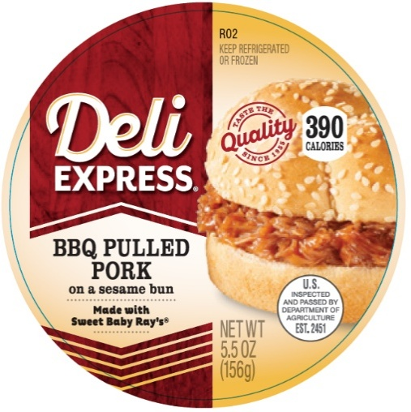 | - 1915013  - 1915020  - 1915024  - 1915051  - 1915065  - 1915071  - 1915093  - 1915104  - 1915114  - 1915135  - 1915140  - 1915148  - 1915169  - 1915218  - 1915226  - 1915232  - 1915254  - 1915288  - 1915301
 | 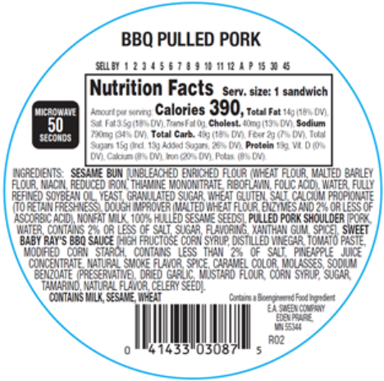 | Lot code information can be found on individual product packages on the ingredient label next to the barcode.

